Project 1
<The Dice Game>

CIS-18A 86625
Name: James Small
Date: 10/29/10

Introduction

Title: The Dice Game

This is a very basic dice rolling game. I stole elements from the casino game Craps, and also from Yahtzee. You place your bet on one of 8 possible outcomes of the pair of dice. You start with a bankroll of $10,000.00 and go from there. Each of the different types of bets has different payouts. The game is over when you’re out of money. I setup a scoreboard that shows how many times each number appears so you can try and determine what will the outcome of the next pair of dice be.

Summary

Project size: about 650 lines (100 of which are used to setup the display)
The number of variables: about 50 (including display setup variables)
The number of method: 10

For this project, I started off with an idea for a simple game of dice. I wanted to create a game as it makes the programming more interesting. I spent the first 4 days creating the game using the console for input and output. I was about three quarters done when I felt that the console was boring. It wasn’t much to look at so I wanted to incorporate a gui into it. I started with a basic example from the apply section of lesson 9. It was a basically craps but it had a gui. This was a very basic setup with just a couple of buttons, and that’s it.

From there, I learned a little about setting up the gui. I added all of the necessary buttons and labels as I needed. I did have problems formatting them in a nice fashion. After some research on the internet, I learned about different layouts and decided on the gridlayout with 2 columns so I can display the output like I had envisioned. Lastly on the gui, I used JPanels to separate the two main sections of the display. It took me a little bit to learned how to add buttons and labels correctly into the panels and then add borders to the gui. Once the gui was basically ready, I started on the program. The gui was a bit of a challenge and there was a lot of trial and error before ending up where I had envisioned in the final product.

Since I had already wrote most of the program on the console, I had to convert what I had done using the gui as output instead of the console. This wasn’t a particularly difficult task, just a little time consuming. Looking back afterwards, I probably could have used some sort of array and loops to eliminate some of the redundant code with slightly different verbage. By the time I thought of this though, I was too far along to look back. Maybe that’s something for the next project.

I broke up the methods as efficiently as possible to make the flow of the program very simple. Basically, wait for a button to be pressed, and run the corresponding method for the button pressed. Overall, I’m satisfied with the program with the time I put into it, but see many areas for improvement, and also many areas to reduce the amount of code needed. I used may if/else control structures, along with do/while loops, and a few switch’s to control what happens based on the bet selected.

It ended up taking me about a week to finish the project. I could have probably tried many other more challenging ideas, especially with the gui. I enjoyed the research and effort it took to learn about such things, even though we haven’t gotten to that point in the book.

Description
The basic flow of the program is very simple, what until the user presses a button, and react accordingly. Each button has a different method that is ran.

FlowChart
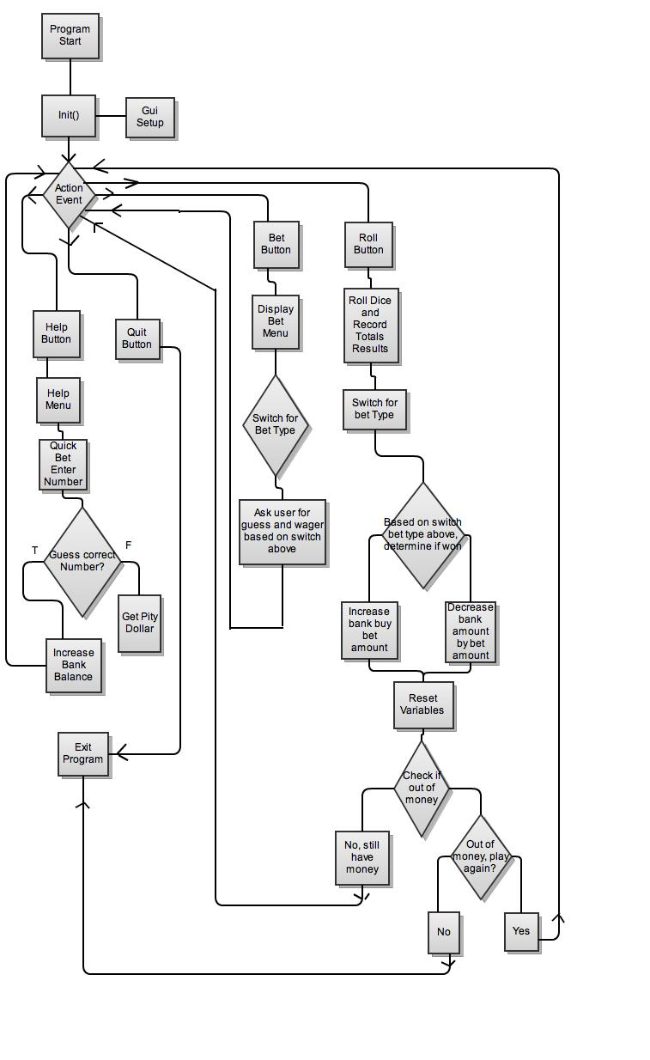

Pseudo Code

Initialize
Gui Setup

If Quit Button Pressed
Exit Game

Else if Help Button Pressed
Display Help Message
Play Quick Bet
Ask user for a one roll guess, 1 to 6
If win Give them 1000
If lose Give them 1

Else if Bet Button Pressed
Display Bet Menu
Switch for answer
Ask for current guess depending on type of bet entered
Get bet Amount

Else if Roll Button Pressed
Check if bet already placed
Roll both dice using dice()
Use switch’s to increase count for each dice rolled
Run Results()
Switch betStringInt
Determine if winner based on type of bet and answer for that bet
Reset current bet information
Check if out of money
If user wants to continue to play
Reset rest of values back to default
If no, quit

Screen Shot Input and Outputs

Main Screen
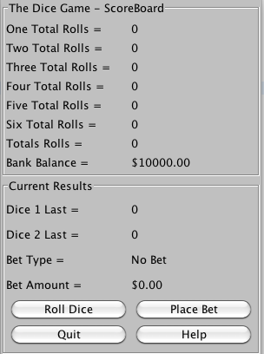

Bet Menu

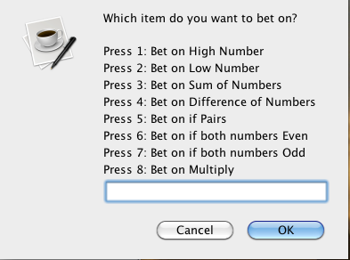

Example Bet

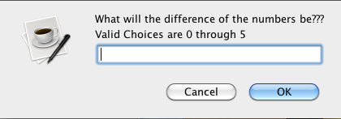
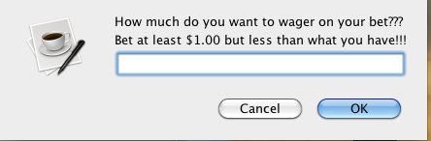

Winner

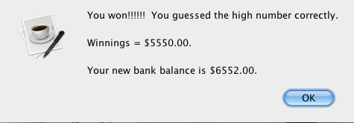

Help Menu

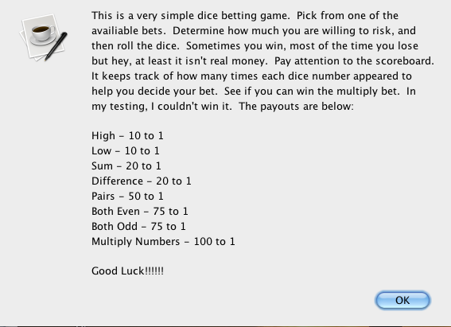

Results after a few rolls showing scoreboard

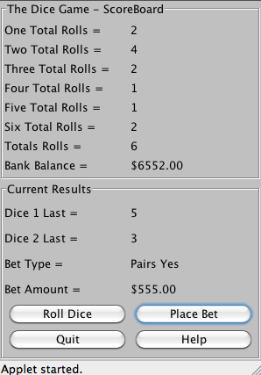

Major Variables

Type | Variable Name | Description | Location
Integer | betDollarAmount | Current Bet Dollar Amount | betMenu(), results()
 | Dice1Value | Value of Dice 1 | betMenu(), results()
 | Dice2Value | Value of Dice 2 | betMenu(), results()
 | betStringInt | Current Bet Value, 1 to 8 | betMenu(), results()
 | betNumber | Current Bet Number | betMenu(), results()
 | Temp | Used to help calculate results | results(),quickBet()
 | rollAmount | Tracks total amount of rolls | betMenu(), results()
 | oneAmount | Tracks occurrence of 1 | betMenu(), results()
 | twoAmount | Tracks occurrence of 2 | betMenu(), results()
 | threeAmount | Tracks occurrence of 3 | betMenu(), results()
 | fourAmount | Tracks occurrence of 4 | betMenu(), results()
 | fiveAmount | Tracks occurrence of 5 | betMenu(), results()
 | sixAmount | Tracks occurrence of 6 | betMenu(), results()
 | bankAmount | Tracks bank balance | betMenu(), results(), quickBet()
String | betString | Current Bet Description | labelUpdate(),betMenu(),results()
 | choice | Current choice on menu’s | betMenu(), results(),quickBet()
Boolean | isPair | Used if betting on pairs | betMenu(), results()
 | isEven | Used if betting on even | betMenu(), results()
 | isOdd | Used if betting on odd | betMenu(), results()
JLabel | One | One Label Description | guiSetup()
 | Two | Two Label Description | guiSetup()
 | Three | Three Label Description | guiSetup()
 | Four | Four Label Description | guiSetup()
 | Five | Five Label Description | guiSetup()
 | Six | Six Label Description | guiSetup()
 | rollTotal | Roll Count Description Label | guiSetup()
 | bankTotal | Bank balance description Label | guiSetup()
 | oneValue | Count of 1’s Label | guiSetup(), labelUpdate()
 | twoValue | Count of 2’s Label | guiSetup(), labelUpdate()
 | threeValue | Count of 3’s Label | guiSetup(), labelUpdate()
 | fourValue | Count of 4’s Label | guiSetup()
 | fiveValue | Count of 5’s Label | guiSetup()
 | sixValue | Count of 6’s Label | guiSetup()
 | rollTotalValue | Counts total rolls Label | guiSetup()
 | bankTotalValue | Value of bank balance Label | guiSetup()
 | betAmount | Current Bet Description Label | guiSetup()
 | betType | Type of Guess Label | guiSetup()
 | betAmountValue | Current Bet Value Descripton Label | guiSetup()
 | betTypeValue | Type of Bet Label | guiSetup()
 | Dice1 | Last result dice 1 label | guiSetup()
 | Dice2 | Last result dice 2 label | guiSetup(), labelUpdate()
 | Dice1Label | Dice 1 Description Label | guiSetup()
 | Dice2Label | Dice 2 Description Label | guiSetup()
JButton | Roll | Roll Button | guiSetup(), init()
 | Quit | Quit Button | guiSetup(), init()
 | Help | Help Button | guiSetup(), init()
 | betButton | Roll Dice Button | guiSetup(), init()
JPanel | topPanel | Top Panel Scoreboard | guiSetup()
 | bottomPanel | Bottom panel results and buttons | guiSetup()
Random | Randomizer | Returns random dice value 1 to 6 | Dice()
Java Constructs

Chapter | New syntax and Keywords | Location
2 | public class (class definition) | Public class DiceGame
2 | Import declartion | Import java.awt.*  Import java.swing.*  Import java.util.random
2 | Variable declartion statement | Multiple at beginning of program
2 | Assignment Operator | Many times throughout program
2 | Integer.parseInt(String s) | Used throughout to convert choices to int’s
4 | If/else selection structure | Used throughout program
4 | Nested if/else statements | Used when dealing with pairs, even, and odd
4 | Compound Assignment Operators | Used when adding to any totals, bank balance
4 | Increment Operator | Used when adding to counts,numbers, rolls,etc
4 | Extends | DiceGame extends Japplet,
5 | Switch | Used in BetMenu() and Results() for each bet type selected. Roller() to increment dice totals
5 | Break; | Used in every switch statement throughout
5 | Logical operators | Used when asking user input to determine if results are within valid range || and &&
 | Do/while loops | Used on user input, waiting for number in valid range of numbers
6 | Abs() | Used when determining difference of numbers
11 | JOPtionPane | User for input and output with dialog boxes
11 | JLabel | Used on scoreboard for almost everything
11 | JButton | Used for input buttons
11 | JPanel | Used to separate into two sections on gui
11 | ActionEvent | Waits for input from the four buttons on gui
11 | Action Listener | Listens for events in program
11 | GridLayout | Used in Gui to create columns

Reference
- Textbook
- Found border tutorials and examples from http://leepoint.net/notes-java/GUI-appearance/borders/15bordersex.html
- Grid Layout: http://download.oracle.com/javase/1.4.2/docs/api/java/awt/GridLayout.html
- Listener and Action Event from Apply Examples in Lesson 9

Program

//The code doesn’t copy and paste well out of Eclipse into word. The spacing seems to be off so that’s why it looks so funny below.

import java.awt.*;
import java.awt.event.*;
import javax.swing.*;
import javax.swing.border.Border;
import java.util.Random;

public class DiceGame extends JApplet implements ActionListener {

private static final long serialVersionUID = 10101010;

//Gui Variables
private JLabel one,two,three,four,five,six,rollTotal,bankTotal;
private JLabel oneValue,twoValue,threeValue,fourValue,fiveValue,sixValue,rollTotalValue,bankTotalValue;
private JLabel betAmount,betType,betAmountValue,betTypeValue,dice1,dice2,dice1Label,dice2Label;
private JButton roll,quit,betButton,help;
private JPanel topPanel,bottomPanel;

//Rest of the variables, non gui
private int rollAmount = 0,oneAmount = 0,twoAmount = 0,threeAmount = 0,fourAmount = 0,fiveAmount = 0,sixAmount = 0,bankAmount = 10000;
private String betString = "No Bet";
private boolean isPair, isEven,isOdd;
private int betDollarAmount = 0, dice1Value = 0, dice2Value = 0, betStringInt = 0, betNumber = 0,temp = 0;
Random randomizer = new Random(); // random object
private String choice; // current menu choice

public void init()
{
guiSetup(); // Run's method to setup gui
} // end init method

public void actionPerformed( ActionEvent e ) // waits for action performed
{
if (e.getSource() == quit) // if quit button, exit program
{
System.exit(0);
}
else if (e.getSource() == help) // If help button, run help menu, then quick bet methods
{
help();
quickBet();
}
else if (e.getSource() == betButton) // if bet button, run betMenu method
{
betMenu();
}
else if (e.getSource() == roll) // if roll button pressed, run roller method
{
roller();
}

labelUpdate(); // update labels on gui before beginning to wait for next action
} // end action performed method

public void labelUpdate() // update gui labels based on current values
{
oneValue.setText(Integer.toString(oneAmount));
twoValue.setText(Integer.toString(twoAmount));
threeValue.setText(Integer.toString(threeAmount));
fourValue.setText(Integer.toString(fourAmount));
fiveValue.setText(Integer.toString(fiveAmount));
sixValue.setText(Integer.toString(sixAmount));
rollTotalValue.setText(Integer.toString(rollAmount));
bankTotalValue.setText("$" + Integer.toString(bankAmount) + ".00");
betAmountValue.setText("$" + Integer.toString(betDollarAmount) + ".00");
betTypeValue.setText(betString);
dice1Label.setText(Integer.toString(dice1Value));
dice2Label.setText(Integer.toString(dice2Value));
} // end labelUpdate method

public void help() // display help menu
{
//help message
JOptionPane.showMessageDialog(
null,"This is a very simple dice betting game. Pick from one of the\n" +
"availiable bets. Determine how much you are willing to risk, and\n" +
"then roll the dice. Sometimes you win, most of the time you lose\n" +
"but hey, at least it isn't real money. Pay attention to the scoreboard.\n" +
"It keeps track of how many times each dice number appeared to\n" +
"help you decide your bet. See if you can win the multiply bet. In \n" +
"my testing, I couldn't win it. The payouts are below:\n\n" +
"High - 10 to 1\nLow - 10 to 1\nSum - 20 to 1\nDifference - 20 to 1\nPairs - 50 to 1\n" +
"Both Even - 75 to 1\nBoth Odd - 75 to 1\nMultiply Numbers - 100 to 1\n\nGood Luck!!!!!!","***The Dice Game***", // Output results
JOptionPane.INFORMATION_MESSAGE );
} // end help method

public void betMenu() // display bet menu and receive bet amount
{
do // display bet menu and wait for user input.
{
choice = JOptionPane.showInputDialog(null,
"Which item do you want to bet on?\n\n" +
"Press 1: Bet on High Number\n" +
"Press 2: Bet on Low Number\n" +
"Press 3: Bet on Sum of Numbers\n" +
"Press 4: Bet on Difference of Numbers\n" +
"Press 5: Bet on if Pairs\n" +
"Press 6: Bet on if both numbers Even\n" +
"Press 7: Bet on if both numbers Odd\n" +
"Press 8: Bet on Multiply","***The Dice Game***",JOptionPane.INFORMATION_MESSAGE );
}while((Integer.parseInt(choice)) > 8 || (Integer.parseInt(choice)) < 1);

betStringInt = Integer.parseInt(choice); // set betStringInt based on choice entered above

switch(Integer.parseInt(choice)) // switch based on bet type entered.
{
case 1: // if high number bet selected
do
{
choice = JOptionPane.showInputDialog(null,
"What will the high number be???\n" +
"Valid Choices are 1 through 6","***The Dice Game***",JOptionPane.INFORMATION_MESSAGE );
}while((Integer.parseInt(choice)) > 6 || (Integer.parseInt(choice)) < 1);

betString = "High is " + Integer.parseInt(choice); // set betString to bet choice and value
break;
case 2: // if low number bet selected
do
{
choice = JOptionPane.showInputDialog(null,
"What will the low number be???\n" +
"Valid Choices are 1 through 6","***The Dice Game***",JOptionPane.INFORMATION_MESSAGE );
}while((Integer.parseInt(choice)) > 6 || (Integer.parseInt(choice)) < 1);

betString = "Low is " + Integer.parseInt(choice); // set betString to bet choice and value

break;
case 3: // if sum of numbers bet selected
do
{
choice = JOptionPane.showInputDialog( null,
"What will the sum of the numbers be???\n" +
"Valid Choices are 2 through 12","***The Dice Game***",JOptionPane.INFORMATION_MESSAGE );
}while((Integer.parseInt(choice)) > 12 || (Integer.parseInt(choice)) < 2);

betString = "Sum is " + Integer.parseInt(choice); // set betString to bet choice and value
break;
case 4: // if difference of numbers bet selected
do
{
choice = JOptionPane.showInputDialog( null,
"What will the difference of the numbers be???\n" +
"Valid Choices are 0 through 5","***The Dice Game***",JOptionPane.INFORMATION_MESSAGE );
}while((Integer.parseInt(choice)) > 5 || (Integer.parseInt(choice)) < 0);

betString = "Difference is " + Integer.parseInt(choice); // set betString to bet choice and value
break;
case 5: // if pairs bet selected
choice = Integer.toString(JOptionPane.showConfirmDialog(null,
"Will it be pairs, yes or no","***The Dice Game***",JOptionPane.INFORMATION_MESSAGE ));

if(Integer.parseInt(choice) == 0) // if betting on pairs
{
betString = "Pairs Yes"; // set betString to bet choice and value
isPair = true;
}
else // if betting on not pairs
{
betString = "Pairs No"; // set betString to bet choice and value
isPair = false;
}
break;
case 6: // if even bet selected
choice = Integer.toString(JOptionPane.showConfirmDialog(null,
"Will both dice be even, yes or no??","***The Dice Game***",JOptionPane.INFORMATION_MESSAGE ));

if(Integer.parseInt(choice) == 0) // if betting on even
{
betString = "Even Yes"; // set betString to bet choice and value
isEven = true;
}
else // if betting on not even
{
betString = "Even No"; // set betString to bet choice and value
isEven = false;
}
break;
case 7: // if odd bet selected
choice = Integer.toString(JOptionPane.showConfirmDialog(null,
"Will both dice be odd, yes or no??","***The Dice Game***",JOptionPane.INFORMATION_MESSAGE ));

if(Integer.parseInt(choice) == 0) // if betting on odd
{
betString = "Odd Yes"; // set betString to bet choice and value
isOdd = true;
}
else // if betting on not odd
{
betString = "Odd No"; // set betString to bet choice and value
isOdd = false;
}
break;
case 8: // if multiply bet is selected
do
{
choice = JOptionPane.showInputDialog(null,
"What will be the result if both numbers are multiplied???\n" +
"Valid Choices are 1 through 36","***The Dice Game***",JOptionPane.INFORMATION_MESSAGE );
}while((Integer.parseInt(choice)) > 36 || (Integer.parseInt(choice)) < 1);

betString = "Multiply is " + Integer.parseInt(choice); // set betString to bet choice and value
break;
default:
break;
}

betNumber = Integer.parseInt(choice); // set bet choice as betNumber variable

do // ask user how much to wager, constraints of 1 to bank balance
{
choice = JOptionPane.showInputDialog( null,
"How much do you want to wager on your bet???\n" +
"Bet at least $1.00 but less than what you have!!!","***The Dice Game***",JOptionPane.INFORMATION_MESSAGE );
}while((Integer.parseInt(choice)) > bankAmount || (Integer.parseInt(choice)) < 1);

betDollarAmount = Integer.parseInt(choice); //set current bet dollar amount to input above
} // End betMenu method

public void roller() //roll dice and record results
{
if(betDollarAmount == 0) // if current bet is 0, tell user to make a bet first
{
JOptionPane.showMessageDialog(
null,"You didn't place a bet\nPlace a bet before rolling the dice","***The Dice Game***",
JOptionPane.INFORMATION_MESSAGE );
}
else // if current bet is not 0
{
// run dice() method for both dice, and increase roll count
dice1Value = dice();
dice2Value = dice();
rollAmount++;

switch(dice1Value) // switch on dice1Value to increase count per number
{
case 1:
oneAmount++;
break;
case 2:
twoAmount++;
break;
case 3:
threeAmount++;
break;
case 4:
fourAmount++;
break;
case 5:
fiveAmount++;
break;
case 6:
sixAmount++;
break;
default:
break;
}

switch(dice2Value) // switch on dice2Value to increase count per number
{
case 1:
oneAmount++;
break;
case 2:
twoAmount++;
break;
case 3:
threeAmount++;
break;
case 4:
fourAmount++;
break;
case 5:
fiveAmount++;
break;
case 6:
sixAmount++;
break;
default:
break;
}

results(); // run results method
}
} // end roller method

public void results() // results method to determine if winner or not
{
switch(betStringInt) // switch based on type of bet entered
{
case 1: // if high bet
if(dice1Value > dice2Value) // determine high number based on dice rolled
temp = dice1Value;
else
temp = dice2Value;

if(betNumber == temp) // if guessed high number
{
bankAmount += (betDollarAmount * 10); // increase bank balance based on wager and odds, tell user they won.

JOptionPane.showMessageDialog(
null,"You won!!!!!! You guessed the high number correctly.\n\nWinnings = $" + (betDollarAmount * 10) + ".00.\n\nYour new bank balance is $" + bankAmount + ".00.","Winner Winner Chicken Dinner", // Output results
JOptionPane.INFORMATION_MESSAGE );
}
else // if didn't guess high number
{
JOptionPane.showMessageDialog(
null,"You lose. Try again next time","Sucks to be you", // Output results
JOptionPane.INFORMATION_MESSAGE );

bankAmount -= betDollarAmount; // decrease bank balance by wager
}
break;
case 2:
if(dice1Value > dice2Value) // determine low number based on roll
temp = dice2Value;
else
temp = dice1Value;

if(betNumber == temp) // if guessed low number
{
bankAmount += (betDollarAmount * 10); // increase bank balance based on wager and odds, tell user they won.

JOptionPane.showMessageDialog(
null,"You won!!!!!! You guessed the low number correctly.\n\nWinnings = $" + (betDollarAmount * 10) + ".00.\n\nYour new bank balance is $" + bankAmount + ".00.","Winner Winner Chicken Dinner", // Output results
JOptionPane.INFORMATION_MESSAGE );
}
else // if lost
{
JOptionPane.showMessageDialog(
null,"You lose. Try again next time","Sucks to be you", // Output results
JOptionPane.INFORMATION_MESSAGE );

bankAmount -= betDollarAmount; // decrease bank balance by wager
}
break;
case 3:
if((dice1Value + dice2Value) == betNumber) // if sum of numbers equal bet number
{
bankAmount += (betDollarAmount * 20); // increase bank balance based on wager and odds, tell user they won.

JOptionPane.showMessageDialog(
null,"You won!!!!!! You guessed the sum of the numbers correctly.\n\nWinnings = $" + (betDollarAmount * 20) + ".00.\n\nYour new bank balance is $" + bankAmount + ".00.","Winner Winner Chicken Dinner", // Output results
JOptionPane.INFORMATION_MESSAGE );
}
else // if lost
{
JOptionPane.showMessageDialog(
null,"You lose. Try again next time","Sucks to be you", // Output results
JOptionPane.INFORMATION_MESSAGE );

bankAmount -= betDollarAmount; // decrease bank balance by wager
}
break;
case 4:
if(betNumber == Math.abs(dice1Value - dice2Value)) // if difference of numbers equals bet number
{
bankAmount += (betDollarAmount * 20); // increase bank balance based on wager and odds, tell user they won.

JOptionPane.showMessageDialog(
null,"You won!!!!!! You guessed the difference of the numbers correctly.\n\nWinnings = $" + (betDollarAmount * 20) + ".00.\n\nYour new bank balance is $" + bankAmount + ".00.","Winner Winner Chicken Dinner", // Output results
JOptionPane.INFORMATION_MESSAGE );
}
else // if lost
{
JOptionPane.showMessageDialog(
null,"You lose. Try again next time","Sucks to be you", // Output results
JOptionPane.INFORMATION_MESSAGE );

bankAmount -= betDollarAmount; // decrease bank balance by wager
}
break;
case 5:
if(dice1Value == dice2Value) // if dice rolled pairs
{
if(isPair) // if bet there will be pairs
{
bankAmount += (betDollarAmount * 50); // increase bank balance based on wager and odds, tell user they won.

JOptionPane.showMessageDialog(
null,"You won!!!!!! You guessed the numbers would be pairs correctly.\n\nWinnings = $" + (betDollarAmount * 50) + ".00.\n\nYour new bank balance is $" + bankAmount + ".00.","Winner Winner Chicken Dinner", // Output results
JOptionPane.INFORMATION_MESSAGE );
}
else // if lost
{
JOptionPane.showMessageDialog(
null,"You lose. Try again next time","Sucks to be you", // Output results
JOptionPane.INFORMATION_MESSAGE );

bankAmount -= betDollarAmount; // decrease bank balance by wager
}
}
else // if dice didn't roll pairs
{
if(isPair) // lost if bet there will be pairs
{
JOptionPane.showMessageDialog(
null,"You lose. Try again next time","Sucks to be you", // Output results
JOptionPane.INFORMATION_MESSAGE );

bankAmount -= betDollarAmount; // decrease bank balance by wager
}
else // win if bet there won't be pairs
{
bankAmount += (betDollarAmount * 50); // increase bank balance based on wager and odds, tell user they won.

JOptionPane.showMessageDialog(
null,"You won!!!!!! You guessed the numbers would be pairs correctly.\n\nWinnings = $" + (betDollarAmount * 50) + ".00.\n\nYour new bank balance is $" + bankAmount + ".00.","Winner Winner Chicken Dinner", // Output results
JOptionPane.INFORMATION_MESSAGE );
}
}
break;
case 6:
if(dice1Value % 2 == 0 && dice2Value % 2 == 0) // check if dice are both even
{
if(isEven) // win if both are even
{
bankAmount += (betDollarAmount * 75); // increase bank balance based on wager and odds, tell user they won.

JOptionPane.showMessageDialog(
null,"You won!!!!!! You guessed the numbers would be even.\n\nWinnings = $" + (betDollarAmount * 75) + ".00.\n\nYour new bank balance is $" + bankAmount + ".00.","Winner Winner Chicken Dinner", // Output results
JOptionPane.INFORMATION_MESSAGE );
}
else // lose if both aren't even
{
JOptionPane.showMessageDialog(
null,"You lose. Try again next time","Sucks to be you", // Output results
JOptionPane.INFORMATION_MESSAGE );

bankAmount -= betDollarAmount; // decrease bank balance by wager
}
}
else // if dice are not even
{
if(isEven) // lose if bet they will be even
{
JOptionPane.showMessageDialog(
null,"You lose. Try again next time","Sucks to be you", // Output results
JOptionPane.INFORMATION_MESSAGE );

bankAmount -= betDollarAmount; // decrease bank balance by wager
}
else // win if dice not even
{
bankAmount += (betDollarAmount * 75); // increase bank balance based on wager and odds, tell user they won.

JOptionPane.showMessageDialog(
null,"You won!!!!!! You guessed the numbers would be even.\n\nWinnings = $" + (betDollarAmount * 75) + ".00.\n\nYour new bank balance is $" + bankAmount + ".00.","Winner Winner Chicken Dinner", // Output results
JOptionPane.INFORMATION_MESSAGE );
}
}
break;
case 7:
if(dice1Value % 2 != 0 && dice2Value % 2 != 0) // if dice are both odd
{
if(isOdd) // win if bet they both were odd
{
bankAmount += (betDollarAmount * 75); // increase bank balance based on wager and odds, tell user they won.

JOptionPane.showMessageDialog(
null,"You won!!!!!! You guessed the numbers would be odd.\n\nWinnings = $" + (betDollarAmount * 75) + ".00.\n\nYour new bank balance is $" + bankAmount + ".00.","Winner Winner Chicken Dinner", // Output results
JOptionPane.INFORMATION_MESSAGE );
}
else // lose if both aren't odd
{
JOptionPane.showMessageDialog(
null,"You lose. Try again next time","Sucks to be you", // Output results
JOptionPane.INFORMATION_MESSAGE );

bankAmount -= betDollarAmount; // decrease bank balance by wager
}
}
else // if dice are both not odd
{
if(isOdd) // lose if bet both are odd
{
JOptionPane.showMessageDialog(
null,"You lose. Try again next time","Sucks to be you", // Output results
JOptionPane.INFORMATION_MESSAGE );

bankAmount -= betDollarAmount; // decrease bank balance by wager
}
else // win if both aren't odd
{
bankAmount += (betDollarAmount * 75); // increase bank balance based on wager and odds, tell user they won.

JOptionPane.showMessageDialog(
null,"You won!!!!!! You guessed the numbers would be odd.\n\nWinnings = $" + (betDollarAmount * 75) + ".00.\n\nYour new bank balance is $" + bankAmount + ".00.","Winner Winner Chicken Dinner", // Output results
JOptionPane.INFORMATION_MESSAGE );
}
}
break;
case 8:
if(dice1Value * dice2Value == betNumber) // if multiply of numbers is bet number
{
bankAmount += (betDollarAmount * 100); // increase bank balance based on wager and odds, tell user they won.

JOptionPane.showMessageDialog(
null,"You won!!!!!! You guessed the result of multiplying the numbers.\n\nWinnings = $" + (betDollarAmount * 100) + ".00.\n\nYour new bank balance is $" + bankAmount + ".00.","Winner Winner Chicken Dinner", // Output results
JOptionPane.INFORMATION_MESSAGE );
}
else // if multiply of numbers not bet number
{
JOptionPane.showMessageDialog(
null,"You lose. Try again next time","Sucks to be you", // Output results
JOptionPane.INFORMATION_MESSAGE );

bankAmount -= betDollarAmount; // decrease bank balance by wager
}
break;
default:
break;
}

//This round over, reset variables to default for next roll
betString = "No Bet";
temp = 0;
betStringInt = 0;
betDollarAmount = 0;

if(bankAmount == 0) // if out of money, let user know that. Ask if want to play agin.
{
choice = Integer.toString(JOptionPane.showConfirmDialog(null,
"Game over. You are broke!!!\n\nDo you want to play again?"));

if(Integer.parseInt(choice) == 0) // if yes play again
{
//reset all variables back to default
bankAmount = 10000;
oneAmount = 0;
twoAmount = 0;
threeAmount = 0;
fourAmount = 0;
fiveAmount = 0;
sixAmount = 0;
rollAmount = 0;
}
else // if not play again, exit game
{
System.exit(0);
}
}
} // end results method

public int dice() // randomize dice
{
return randomizer.nextInt(6) + 1; // random number 1 to 6
} // end dice method

public void quickBet() // plays quick bet game from help menu
{
do // ask user for value 1 to 6
{
choice = JOptionPane.showInputDialog(null,
"Since you looked at the help menu, you get to play\n" +
"Quick Bet!! Very simple, pick a number between 1 and 6.\n" +
"Guess right and win an easy $1,000.00. Good Luck\n\nWhat's your guess??","***The Dice Game***",JOptionPane.INFORMATION_MESSAGE );
}while((Integer.parseInt(choice)) > 6 || (Integer.parseInt(choice)) < 1);

temp = Integer.parseInt(choice); // set temp variable as guess

if(dice() == temp) // if 1 dice rolled matches guess, say winner
{
JOptionPane.showMessageDialog(
null,"Guess what!!!! You won!!!!!!\n" +
"That was an easy $1,000.00 now wasn't it.","***The Dice Game***", // Output results
JOptionPane.INFORMATION_MESSAGE );
bankAmount += 1000; // increase bank balance by 1000
}
else // if didn't guess correctly
{
JOptionPane.showMessageDialog(
null,"You lost but you didn't lose any money, which is a good thing.\n" +
"Since I feel sorry for you, here's a pity $1.00. Enjoy","***The Dice Game***", // Output results
JOptionPane.INFORMATION_MESSAGE );
bankAmount += 1; // increase bank balance by 1 for pity
}
} // end quickBet method

public void guiSetup() // Setup Gui portion of program
{
Container c = getContentPane(); // Setup container with gridlayout with 1 column
c.setLayout(new GridLayout(0,1));

//Setup etched border with titles
Border etched = BorderFactory.createEtchedBorder();
Border title = BorderFactory.createTitledBorder(etched, "The Dice Game - ScoreBoard");
Border title2 = BorderFactory.createTitledBorder(etched, "Current Results");

//Setup top panel with gridlayout and two columns
topPanel = new JPanel();
topPanel.setLayout(new GridLayout(0,2));
topPanel.setBackground(Color.lightGray);
topPanel.setBorder(title);

//Setup botttom panel with gridlayout and two columns
bottomPanel = new JPanel();
bottomPanel.setLayout(new GridLayout(0,2));
bottomPanel.setBackground(Color.lightGray);
bottomPanel.setBorder(title2);

// setup one count labels and add to top panel
one = new JLabel("One Total Rolls =");
topPanel.add(one);
oneValue = new JLabel(Integer.toString(oneAmount));
topPanel.add(oneValue);

// setup two count labels and add to top panel
two = new JLabel("Two Total Rolls =");
topPanel.add(two);
twoValue = new JLabel(Integer.toString(twoAmount));
topPanel.add(twoValue);

// setup three count labels and add to top panel
three = new JLabel("Three Total Rolls =");
topPanel.add(three);
threeValue = new JLabel(Integer.toString(threeAmount));
topPanel.add(threeValue);

// setup four count labels and add to top panel
four = new JLabel("Four Total Rolls =");
topPanel.add(four);
fourValue = new JLabel(Integer.toString(fourAmount));
topPanel.add(fourValue);

// setup five count labels and add to top panel
five = new JLabel("Five Total Rolls =");
topPanel.add(five);
fiveValue = new JLabel(Integer.toString(fiveAmount));
topPanel.add(fiveValue);

// setup six count labels and add to top panel
six = new JLabel("Six Total Rolls =");
topPanel.add(six);
sixValue = new JLabel(Integer.toString(sixAmount));
topPanel.add(sixValue);

// setup roll count labels and add to top panel
rollTotal = new JLabel("Totals Rolls =");
topPanel.add(rollTotal);
rollTotalValue = new JLabel(Integer.toString(rollAmount));
topPanel.add(rollTotalValue);

// setup bank balance labels and add to top panel
bankTotal = new JLabel("Bank Balance = ");
topPanel.add(bankTotal);
bankTotalValue = new JLabel("$" + Integer.toString(bankAmount) + ".00");
topPanel.add(bankTotalValue);

// setup dice1 labels and add to bottom panel
dice1 = new JLabel("Dice 1 Last = ");
bottomPanel.add(dice1);
dice1Label = new JLabel(Integer.toString(dice1Value));
bottomPanel.add(dice1Label);

// setup dice2 labels and add to bottom panel
dice2 = new JLabel("Dice 2 Last = ");
bottomPanel.add(dice2);
dice2Label = new JLabel(Integer.toString(dice2Value));
bottomPanel.add(dice2Label);

// setup bet type labels and add to bottom panel
betType = new JLabel("Bet Type = ");
bottomPanel.add(betType);
betTypeValue = new JLabel(betString);
bottomPanel.add(betTypeValue);

// setup bet amount labels and add to bottom panel
betAmount = new JLabel("Bet Amount = ");
bottomPanel.add(betAmount);
betAmountValue = new JLabel("$" + Integer.toString(betDollarAmount) + ".00");
bottomPanel.add(betAmountValue);

// setup roll button and add to bottom panel
roll = new JButton("Roll Dice");
roll.addActionListener(this);
bottomPanel.add(roll);

// setup bet button and add to bottom panel
betButton = new JButton("Place Bet");
betButton.addActionListener(this);
bottomPanel.add(betButton);

// setup quit button and add to bottom panel
quit = new JButton("Quit");
quit.addActionListener(this);
bottomPanel.add(quit);

// setup help button and add to bottom panel
help = new JButton("Help");
help.addActionListener(this);
bottomPanel.add(help);

//add panels to container
c.add(topPanel, BorderLayout.NORTH);
c.add(bottomPanel, BorderLayout.SOUTH);

//set size of applet
setSize(300,410);
} // end guiSetup method
} // end dice game method

